e-Science in Biodiversity: A case study on Species Distribution Modeling Environment
Karla Donato Fook^{1,2}, Antônio Miguel Vieira Monteiro¹, Gilberto Câmara¹, Marco A. Casanova³

¹Image Processing Division – National Institute of Space Research –INPE
São José dos Campos – SP – Brazil
²Departmento Acadêmico de Informática
Centro Federal de Educação Tecnológica do Maranhão – CEFET-MA
São Luís – MA – Brazil
³Departamento de Informática – PUC-Rio
Rio de Janeiro – RJ – Brazil

{karla, miguel, gilberto}@dpi.inpe.br, casanova@inf.puc-rio.br

Abstract
Biodiversity research deals with huge data volume from diverse sources, multidisciplinary analysis and synthesis, and wish to cooperate in distributed environment. Scientists can to cooperate with the knowledge obtained at the end of a modeling through their results, besides data. This paper presents an approach to support the cooperation among the researchers of a species distribution modeling network. For this, we propose a catalog that allows the sharing of modeling results and its context, here called model instances.
1. Introduction
Biodiversity research uses tools that allow doing inferences about diversity and abundance of species in different areas. By combining presences of species data with electronic cartography by several algorithms, estimating niches of species and their areas of distribution becomes possible at resolutions higher than it was possible a few years ago [Soberón and Peterson, 2004]. Computational tools such on species distribution modeling, aid in the analysis and solution of problems as forecast of species distribution and impact of climatic changes, beyond of problems related to expanding invader species. Researchers need a computational infrastructure to support local and global research and to spread information to a diverse set of users [Ramamurthy, 2006].
Projects related to biodiversity and e-Science stands out for supporting the scientific communities through cooperation of resources. Collaboration among researchers is not only in the change of data, but also in the interaction among the scientific models and their implementations, as well as in the programs aggregation and experiments results [Osthoff, 2004]. Besides data and services, acquired knowledge is a resource that supports discoveries and continuous development of new studies and technologies. Knowledge obtained at the end of a modeling for researchers is a key resource to be shared. This knowledge can be included in experiments results and its context.
This approach supports the cooperation in a modeling network through sharing modeling results of species distribution. We propose the creation of a Model Instance Catalog that supports sharing of knowledge by inferences and reproduction of experiments/modeling. A model instance includes model data and metadata, which holds the complete context of modeling results of species distribution. In this case, experiments data need to be catalogued in an integrated way and recovered so that a final result doesn't become an isolated data of the process that generated it.
The catalog will be available in Web, and a web service will allows the creation, cataloguing and recovery of model instances. The service is Web Biodiversity Collaborative Modeling Service – WBCMS [ref. artigo GeoInfo?].
However, one of the main challenges of this approach lives in the composition of model instance. This requests an appropriate treatment to metadata and web semantics will aid in that aspect. The level of abstraction currently involved in invoking a Web Service is relatively low. Then, a Semantic Web service is to raise the level of description such that services are detailed in a way that indicates their capabilities and task achieving character [David de Roure, 2005].
…
This paper is organized as follows. Section 2 addresses some points about e-Science and Biodiversity. Section 3 presents Model Instances Catalog and its characteristics. Section 4 presents a case study. Finally, section 5 concludes the paper and discusses further work that should be undertaken.
2. Related Work
There is an increasing interest in the e-Science field. The U.K. Research Councils define e-science as: [Newman, 2003]
Large-scale science carried out through distributed global collaborations enabled by networks, requiring access to very large data collections, very large-scale computing resources, and high-performance visualization.
e_science experiments have a process of knowledge discovery in common. Key technologies and trends have enabled a new generation of data services in the scientific community. Some examples of these technologies are: World Wide Web; Open standards, frameworks, and conventions; Extensible Markup Language (XML); Web services; Digital libraries; Grid computing; Data portals and federated, distributed servers; Geographic Information Systems; Ontologies and Semantic Web [Ramamurthy, 2006]. This scenery create new challenges to the research community, as to develop a kind integrated distributed infrastructure which help process, disseminate, and share vast quantities of scientific information. These challenges lead to data representation, management, storage, and access problems.
A wide range of research areas holds features of e-Science field, including Biodiversity. For instance, scientists that works with the predictive species distribution modeling need a modeling architecture of ecological niche with the ability to access great volumes of data environmental such as climate, vegetation, topography and land use.
Biodiversity data include geographical data (maps of areas where species were found), and metadata of specific domains (habitat and ecosystem descriptions). This georeferenced biodiversity data can be used to predict effects of climate change; to determine safe sites for field trials of genetically modified organisms, and to predict best places to set up new protected areas. Its applications must be able to locate and achieving interoperability. This is more difficult, because geospatial data are much more complex than conventional data, about both syntax and semantics [Breitman, 2006].
...
…
…
Specification efforts such as ISO/TC 211, OGC e W3C assure the interoperability in the domain GEO [Alameh, 2001; Bernard, et al., 2003; Tu, et al., 2002]. Some protocols and standards created and adopted are XML, GML (Geography Markup Language), SOAP (Simple Object Access Protocol), OWL (Web Ontology Language/W3C), and DAML (DARPA Agent Markup Language) + OIL (Ontology Integration Language).
There are initiatives for geo-metadata creation and maintenance. Digital libraries and many other information systems use metadata elements (author, title, date) to describe data resources. The Dublin Core is a small set (core) of general description elements designed to describe documents, books and other such resources. Another initiative is ISO - International Organization for Standardization, which produces world-wide industrial and commercial standards, called standards. There are actually 2 related standards: ISO 19115 is the abstract definition of the required and optional metadata elements to be created, and ISO 19139, which details the implementation of these elements in XML. (???)
We highlights WS-GIS approach, which developed the design of a SOA-based SDI which aims to integrate, locate, and catalog distributed spatial data sources such as data and services [Leite Jr, 2007].
…
More specifically related to the biodiversity area, we highlight the Global Biodiversity Information Facility Project (GBIF), which promotes development and adoption of standards and protocols for documenting and exchanging biodiversity data [DÄoring and Giovanni, 2004; Hobern, 2004].
…
…
Several approaches apply Grid Computing Technology in e-science area. For instance, Grid Computing was also seen in [Panatkool et al., 2002], that propose a decentralized Paradigm based on model of Computational Grid for GIS. In the integration proposal of Grid Technology with OGC Web Services, Di (2003) approaches Globus Toolkit integration with service system and distribution of geodata NWGISS (NASA Web GIS Software Suite). Such integration provides access services to geodata by data Earth users via data observation in centers as DAACs (NASA Distributed Active Archive Centers).
Some authors highlight the using of Peer-to-Peer (P2P) Grid to solve problems in distributed architectures. Zhao's work describes the services, architecture and application of System Data Virtual GriPhyN - Grid Physics Network [Zhao et al., 2004]. Project as MyGrid [Cirne et al., 2003] propose the Grid Technology for sharing of resources.
…
…
We can highlight some e-science projects related to biodiversity, such as:
• Web Service Multimodal Tools for Biodiversity Research, Assessment and Monitoring – WeBIOS Project aims to provide scientists who work in environmental/biodiversity issues with a system that supports exploratory multimodal queries over heterogeneous biodiversity data sources [Unicamp, 2005].
• BiodiversityWorld is a project which aims to make heterogeneous data sources and analytic tools of relevance to biodiversity available in a GRID [Jones et al., 2003a; Jones, 2003]. This project has characteristics such as high performance computing resources are only of use for a small range of self-contained tasks in biodiversity informatics; but a wide range of types of data is to be used, many of these types having their own complex structures.
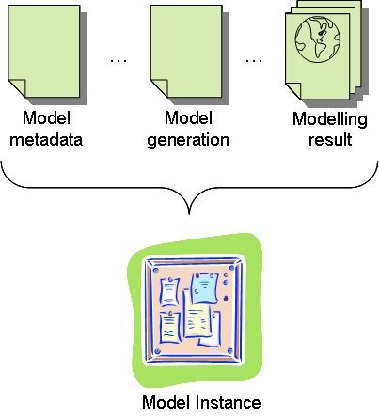
• BioWired project supports a community of scientific organizations, researchers and users, interconnected over a P2P network where anyone can either perform biodiversity data access. P2P architecture uses JXTA protocol. The contribution from all users creates a large distributed database maintained individually by each one of them [Daniela Alvarez, 2005].
…
The works above don't aim at to make available models, or modeling results, for the community. Our approach aims to make available model instances, with modeling results and their embedded knowledge for biodiversity researchers.
...
3. Case Study on Species Distribution Modeling Environment
Catalogue services are required to support the discovery and binding to registered information resources within an information community [OGC, 2006].
…
Consider a distributed environment in which researchers perform the species distribution modeling locally, and wish to share their modeling results by web. In this context we are developing a catalog that contemplates information regarding the generation process of experiments results, and not just results itself. This catalog contemplates Models Instances. We use web services technology for catalog maintenance.
...
…
…
We use modeling results obtained from modeling tool OpenModeller [Canhos, 2004; CRIA, 2005; Guralnick, 2005]. OpenModeller is a spatial distribution modeling tool. The modeling results will be the base of model instance, but other data and metadata will complement it.
…
3.1. Model Instance
Model Instances Catalog is being developed to connect spatial information and experiments of biodiversity researches and their modeling results using a modern architecture.
…
…
Model instances are based on openModeller’s modeling results. However other data and metadata are added to assure that the modeling process is also inserted in the catalog (Figure 2).

Figure 2 – Components’ Model Instance

Figure 2 shows some components’ model instances. A model instance is spatial data and holds the conceptual information about:
• Model such as name, description, author, etc.;
• Model generation, for instance input data, which contains sample of species like a set of occurrence points (latitude/longitude), the modeling algorithms and its parameters;
• Result modeling, which contain a set of environmental layer files, georeferenced maps, etc.
…
It is important to observe, that in the context of the digital geographical information, the metadata aren’t an independent element of the data, but the part of same set [OGC/ISO, 2003].
…
We designed data structure and metadata, and compose model instance. Code 1 presents part of the model instance schema.

<?xml version="1.0" encoding="utf-8" ?>
<xs:schema ... xmlns:xs="http://www.w3.org/2001/XMLSchema">
<xs:complexType name="MdInst">
<xs:complexContent>
<xs:sequence>
<xs:element name="title"
type="xs:string" />
<xs:element name="description"
type="xs:string" />
<xs:element name="author_name"
type="xs:string" />
<xs:element name="org_name"
type="xs:string" />
<xs:element name="language"
type="xs:string" />
<xs:element name="MD_standard_name"
type="xs:string" />
<xs:element name="MD_standard_version"
type="xs:string" />
<xs:element name="contact"
type="xs:string" />
<xs:group ref="model" />
<xs:group ref="model_generation" />
<xs:group ref="modeling_result" />
</xs:sequence>
</xs:complexContent>
</xs:complexType>
...
</xs:schema>

Code 1 – Model instance schema

Code 1 displays elements contained in the model instance schema. There are groups related to data and metadata generated by openModeller modeling tool. Code 2 exhibits model instance schema with part of this data related to Samples.

<xs:group name="Environment">
<xs:sequence>
<xs:element name="Layers"
type="xs:unsignedInt" />
<xs:group ref="Map" />
<xs:group ref="Mask" />
</xs:sequence>
</xs:group>
<xs:group name="Map">
<xs:sequence>
<xs:element name="Filename"
type="xs:string" />
<xs:element name="Categorical"
type="xs:string" />
<xs:element name="Min"
type="xs:string" />
<xs:element name="Max"
type="xs:string" />
</xs:sequence>
</xs:group>
...
<xs:group name="Presence">
<xs:sequence>
<xs:element name="SpeciesName"
type="xs:string" />
<xs:element name="Count"
type="xs:unsignedLong" />
<xs:group ref="CoordinateSystem" />
<xs:group ref="Point" />
</xs:sequence>
</xs:group>
...
<xs:group name="Point">
<xs:sequence>
<xs:element name="X"
type="xs:string" />
<xs:element name="Y"
type="xs:string" />
<xs:element name="Sample"
type="xs:string" />
</xs:sequence>
</xs:group>

Code 2 – Sample Data

Code 2 shows some data about samples data used by modeling process. Metadata of modeling algorithm are part of model instance (code 3).

<xs:group name="Alg_metadata">
<xs:sequence>
<xs:element name="Id"
type="xs:string" />
<xs:element name="Name"
type="xs:string" />
<xs:element name="Version"
type="xs:string" />
<xs:element name="Author"
type="xs:string" />
<xs:element name="CodeAuthor"
type="xs:string" />
<xs:element name="Contact"
type="xs:string" />
<xs:element name="Overview"
type="xs:string" />
</xs:sequence>
</xs:group>
<xs:group name="Alg_parameters"> <xs:sequence>
<xs:element name="Id"
type="xs:string" />
<xs:element name="Value"
type="xs:string" />
</xs:sequence>
</xs:group>

Code 3 – Algorithm Metadata
…
We are developing web services to create model instances, store it in catalog, and access in another moment. It’s Web Biodiversity Collaborative Modeling Service (WBCMS) that consists of two components. Each component has a set of services to perform cataloguing and access to model instances:
• Catalogue Component, which contains a set of services that deals with establishing the necessary data for composing a model instance and inserts it in the catalog;
• Data Handling Component, a set of services that perform the search, recovery and visualization of the existent model instances in the catalog.
…
We implemented a web service prototype using gSOAP and development environment .NET (C++). The prototype allows a client to execute a service to catalog a model instance in the catalog. In another moment, a client can execute web service to accomplish a query in catalog (Figure 4).

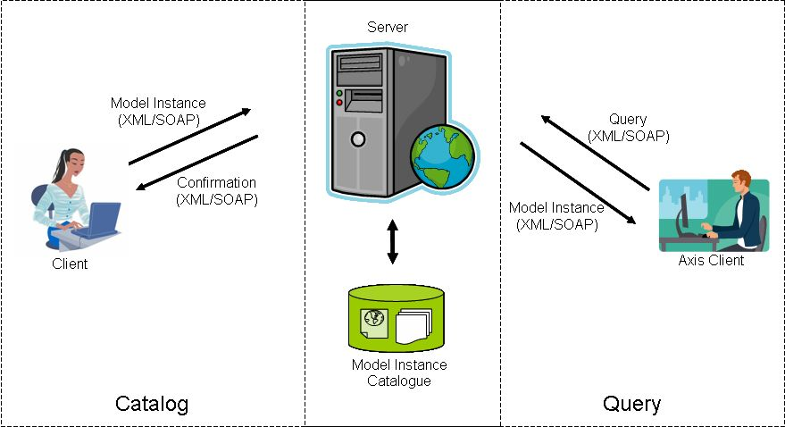
Figure 4 – WBCMS Prototype
…
...
5. Conclusions
This is example text. It is 10 point Times Roman.
Acknowledge

Karla Fook’s work is partially funded by FAPEMA (in Portuguese: Fundação de Amparo à Pesquisa e ao Desenvolvimento Científico e Tecnológico do Maranhão).
References
Alameh, N. 2001. Scalable and Extensible Infrastructures for Distributing Interoperable Geographic Information Services on the Internet. Massachussets Institute of Technology, Massachussets.

Bernard, L., et al. 2003. Interoperability in GI Service Chains-The Way Forward. 6th AGILE Conference on Geographic Information Science, Muenster.

Breitman, K., et al. 2006. Semantic Web: Concepts, Technologies and Applications (NASA Monographs in Systems and Software Engineering), Springer-Verlag New York, Inc., Secaucus, NJ, USA.

Canhos, V. P., et al. 2004. Global biodiversity informatics: setting the scene for a “new world” of ecological modeling. Biodiversity Informatics, 1, 1-13.

Cirne, W., et al. 2003. Running Bag-of-Tasks Applications on Computational Grids: The MyGrid Approach. ICCP - International Conference on Parallel Processing, IEEE Computer Society, Kaohsiung.

CRIA, and FAPESP. 2005. openModeller: Static Spatial Distribution Modelling Tool. edited, CRIA.

Daniela Alvarez, A. S., and A. A. Vaisman. 2005. Peer-To-Peer Databases for e-Science: a Biodiversity Case Study.

DÄoring, M., and R. D. Giovanni. 2004. GBIF Data Access and Database Interoperability: A united protocol for search and retrieval of distributed data. CRIA - Centro de Referência em Informação Ambiental.

David de Roure, N. R. J., and N. R. Shadbolt. 2005. The Semantic Grid: Past, Present, and Future. IEEE, 93, 669-681.

Di, L., et al. 2003. The Integration of Grid Technology with OGC Web Services (OWS) in NWGISS for NASA EOS Data. HPDC12 (Twelfth IEEE International Symposium on High-Performance Distributed Computing) & GGF8 (The Eighth Global Grid Forum), Seattle, Washington, USA.

Guralnick, R., and D. Neufeld. 2005. Challenges building online GIS services to support global biodiversity mapping and analysis: lessons from the Mountain and plains database and informatics project. Biodiversity Informatics, 2, 56-69.

Hobern, D. 2004. Architecture and Tools for Biodiversity Data Exchange. In Converging Sciences Conference, edited, Trento, Italy.

Jones, A. C., et al. 2003a. BiodiversityWorld: An architecture for an extensible virtual laboratory for analysing biodiversity patterns. UK e-Science All Hands Meeting, Cox, S.J., Nottingham, UK.

Jones, A. C., et al. 2003. BiodiversityWorld: An Architecture for an Extensible Virtual, edited.

Leite Jr. F. L., et al. 2007. WS-GIS: Towards a SOA-Based SDI Federation. In: Advances in Geoinformatics, edited by C. Davis. Springer. (in press)

Newman, H. B., et al. 2003. Data-intensive e-science frontier research. Commun. ACM, 46, 68--77.

OGC. 2006, OpenGIS® Catalogue Service Implementation Specification, edited.

OGC/ISO. 2003, Standard ISO 19115 – Geographic Information Metadata. Perfil IDEC, Final Draft, ISO - Spatial Data Infrastructure of Catalonia (IDEC).

Osthoff, C., et al. 2004. MODGRID – Um ambiente na WEB para desenvolvimento e execução de modelos espaciais em um ambiente de Grades Computacionais. LNCC - Laboratório Nacional de Computação Científica, Petrópolis.

Panatkool, A., and S. Laoveeraku. 2002. Decentralized GIS Web Services on Grid. Open source GIS - GRASS users conference, Trento, Italy.

Ramamurthy, M. K. 2006. A new generation of cyberinfrastructure and data services for earth system science education and research. Advances in Geosciences, 8, 69-78.

Soberón, J., and T. Peterson. 2004. Biodiversity informatics: managing and applying primary biodiversity data. The Royal Society, 359, 689 - 698.

Tu, S., et al. 2002. Applications: Achieving interoperability for integration of heterogeneous COTS geographic information systems. 10th ACM international symposium on Advances in geographic information systems, ACM Press, McLean, VA.

Unicamp. 2005. WeBIOS: Web service multimodal tools for strategic biodiversity assessment and monitoring. Edited, Web.

Zhao, Y., et al. 2004. Grid middleware services for virtual data discovery, composition, and integration. 2nd workshop on Middleware for Grid Computing ACM Press, Toronto, Ontario. Canada.

Copyright © 2007, American Association for Artificial Intelligence (www.aaai.org). All rights reserved.
http://www.rcuk.ac.uk/default.htm
http://www.gbif.org/
http://www.lsd.ufcg.edu.br/~nazareno/documentos/ acessoEmGrids/node7.html
http://openmodeller.cria.org.br/
http://www.fapema.br/

