Games on Cellular Spaces: How Mobility affects Equilibrium
Pedro Ribeiro de Andrade Neto1, Antônio Miguel Vieira Monteiro1,
Gilberto Câmara1, Sandra Sandri

1 Image Processing Division (DPI)
National Institute for Space Research (INPE)
São José dos Campos, SP – Brazil
{pedro, miguel, gilberto}@dpi.inpe.br

Abstract. Models of spatial games are commonly described as grids where each cell contains one agent. The agents plays with their neighbors and can reason mainly changing the strategy. This work presents a new model for games on cellular spaces, where each cell contains agents that compete for it, and, instead of changing their strategies, the agents may move in the space. The experiments show that spatial mobility is an important variable concerning spatial games, and also that the best strategy for the proposed game is based on Nash Equilibrium, but it is quite more ambitious.
Keywords:
1 Introduction
Game theory studies situations where players choose different actions in an attempt to maximize their returns. It provides a formal modeling approach to social situations in which decision makers interact with other actors. Game theory has been used as a basis for the study of behaviour in the last decades. Recently, there has been an increased interest on modeling games on cellular automata. The main purpose of studying games on cellular automata is to assess the effects that spatial structures have on adaptation strategies of the players[1]. Most of the games on cellular space use a straightforward extension of the non-spatial games. This spatial extension allows interaction between a cell and its neighbourhood. This iteration allows the same game to be repeated, and the results will influence how the cellular space is populated by the players. As an example, Nowak [2] proposes a spatial prisoner’s dilemma where each cell is given to the player with highest payoff in the neighbourhood. Such games have proven to be useful for modelling biological and economic contexts[1].
Most games on cellular space use an arrangement where each cell has one player and where players interact with their neighbourhoods. The simplest spatial model is a one-dimensional space, where space is divided into two types of players, each player having an evolutionary stable strategy (that is, ….), denoted by strategy-1 and strategy-2. By allowing the players to interact, Hutson and Vickers [3] show that there exists a condition where a travelling wave of players using strategy-1 will replace all players with strategy-2. These games are called “replication-diffusion” games and have proven useful for modelling invasive species in biological contexts [4].

). The original games proposed Since the proof of the Nash Equilibrium [5], there are works related to rational learning [6], dynamics of population [7], and others. But the study of games in the space, and how the space can misshape the development of a game still lack more depth. It can be seen that, in real world, the evolution of a population is clearly connected to intrinsic characteristics of the spatial region where it lives [8].
The resulting spatial evolutionary game theory, which was first used to shed light on the emergence of cooperation, has grown rapidly during the past five years and has proved useful in other biological and economic contexts. Thus, we stress mainly the effects spatial structures have on frequency-dependent selection.
Games in the space actually focus in the evolution of populations, mainly in the study of the origins of altruistic behavior [1, 9], but there are also works in cancer disease [10], linguistics [11], and others. In the majority of this models, each agent is located in a cell of a grid, and plays a game with his neighbors. The agents are static in terms of spatial mobility, but they may change their behavior. Recently, new models with different neighborhood topologies have been proposed to study games in the space. The proposals includes variations of grids, graphs, and some in between structures [12, 13], but the agents have the same characteristics as cited before.
There are some works studying mobility in the space as a possibility of action for the agents. Zhang proposes a model for studying segregation, and agents may exchange their spatial positions if both can get benefit from it [14]. Other models propose to have empty cells, and the agents may move to an empty neighbor [11, 15]. In all these models, the mobility of an agent depends on a social opportunity, of finding another player that agrees in changing the position, or having an old neighbor that has left an empty cell.
The approach of this work is to model the mobility as an choice that does not depend on the other players, and therefore the agents can move according to their will (Section 3). Cells represent spatial regions, and agents within a cell compete for it through a non-cooperative game (Section 2). The objective is to study how characteristics of the space may alter the mobility, and the impact it can cause in the Nash Equilibrium.
2. Non-cooperative games
Given n players, we call non-cooperative a game that, for each player, there are:
- a finite set of pure strategies, representing the possible actions for that player;
- a payoff function, that maps all n-tuples with the individual pure strategies to real numbers, i.e., what happens to that player given the pure strategies of each player.
One mixed strategy is a collection of non-negative numbers corresponding to the pure strategies of a player, in such way that the sum of these values is one. The mixed strategy defines the tendencies of a player, then each time he plays, he will choose randomly one of his pure strategies, based on his mixed strategy.
Nash proved that, given any non-cooperative game of n players, there is always an equilibrium point, a set of mixed strategies for each player that, if a player individually changes his mixed strategy, the best result he may get will be the same as in the equilibrium [5]. This is called Nash Equilibrium.
The non-cooperative game used in the model is based on the chicken game [16]. In this game, a player represents a group of colons. When two players get in a strive, they can choose shoot or not shoot their firearms. If none of them shoots, nothing happens. If only one shoots, the other player runs away, and then the winner receives $1 from the coward group. But, if both decide to shoot, each group pays $10 due to medical cares. This game is symmetric, because both players have the same pure strategies and payoffs, as shown in Table 1.

Table 1. Game results, in pairs (A, B)

 | B shoots | B does not shoot
A shoots | (-10,-10) | (+1,-1)
A does not shoot | (-1,+1) | (0,0)

Suppose two players A and B, with probability of shooting pA and pB , respectively. The expected payoff of player A is -10pA pB + pA - pB . If that A knows exactly the value of pB , it is possible to calculate the best action for A. If pB is greater than 10%, the best option to A is never shoot (pA = 0), and it implies in a payoff of -pB . If pB is less than 10%, A must always shoot (pA = 1), because its payoff will be 1 - 11pB . But, if pB is exactly 10%, all strategies for A lead to the same payoff (-0.1). Therefore, if pA is also fixed at 10%, no other strategy could augment the payoff for Applying the same reasoning for B, we arrive to the conclusion that the game reaches an equilibrium when both players shoot with a probability of 10%.
3. The spatial model
The game takes place in a lattice of 20x20 cells. Each cell is a conflict area, and contains a finite number of agents playing a contest for land. The objective of the game is the same for all agents: to own a cell. Each player starts the game with $200, and the richest player of a given cell is its owner, representing the fittest player of the cell. If two players have the same amount of money in a given cell, the player that stands in the cell for more time is its owner. When the money of a player ends, he is removed from the game.
Initially, the players are divided in three groups of equal size. All the players of a group have the same mixed strategy, and a player cannot identify the strategies of other players, even players of the same group. The three groups correspond to the following possibilities:
- Always use the pure strategy seemingly more profitable, shoot, because it is the only way to earn something, and the opponent will have a payoff at most as bad as his;
- Choose randomly a pure strategy in each game (shoot with chance of 50%);
- Follow Nash Equilibrium, shooting with chance equal to 10%.
Each group has 1200 players (three times the number of cells) randomly spread over the cells. Therefore, there are cells with different quantity of players and strategies when the game starts.
The game has a finite number of turns, and each turn has two steps. In the first step, each agent plays against another agent in the same cell. The confronts are defined choosing randomly the maximum number of pairs without repeating agents in the cell, and then executing the game between the pairs. Cells with an odd number of players have one random idle player in the turn.
The second step defines the dynamical part of the model, the movement. If one agent has lost more than $20 since he arrived the cell, then he is dissatisfied. The value $20 was chosen inferring that two results of -10 without earning any money are sufficient to turn a player dissatisfied. When a player reaches this threshold, he chooses randomly a new cell and moves to it. As the player is physically located in a cell, he can go only to one of the four neighbors (up, down, left and right). Cells located in the border of the lattice have less than four neighbors, and therefore agents inside these cells have less options of movement.
4. Results and discussion
The model was implemented using Lua language, and Figure 1 shows the results. The number of players and the total amount of money of each group diminish along with the game, and as more ambicious a strategy is, sharper is the fall of these values. The model always converges to the situation where there is only one player in each cell, because the expected gain for all players is negative. There are some empty cells at the end of the simulation. This happens because there is a chance of when there are only two players in a cell, both shoot, loose $10, reach the threshold, and then decide to leave the cell.
The results show that the group following the equilibrium has the best results, despite the initial results, and achieve 70% of the cells, but there are some players of other strategies at the end of the game, 18% with strategy 0.5 and 0.25% (one cell) with 1.0. Equilibrium players got the best results at the end, but they did not get the ownership of the cells by their own victories, it was indeed because the other players have lost the money faster. It is possible to see clearly that more aggressive players tend to destroy themselves rapidly, and therefore follow the equilibrium yields to a better chance of surviving. But when there is a small number of more aggressive players they can conquer some cells, and it justifies the number of 0.5 players at the end of the model. As the non-equilibrium strategies lose money faster than the equilibrium, then the initial money has an impact on the model, and players following the equilibrium get more advantage of its increase. If the initial amount of money of each player increases to $400 and to $800, the number of cells belonging to players following equilibrium at the end of the simulation also increases to 75% and 85%, respectively.

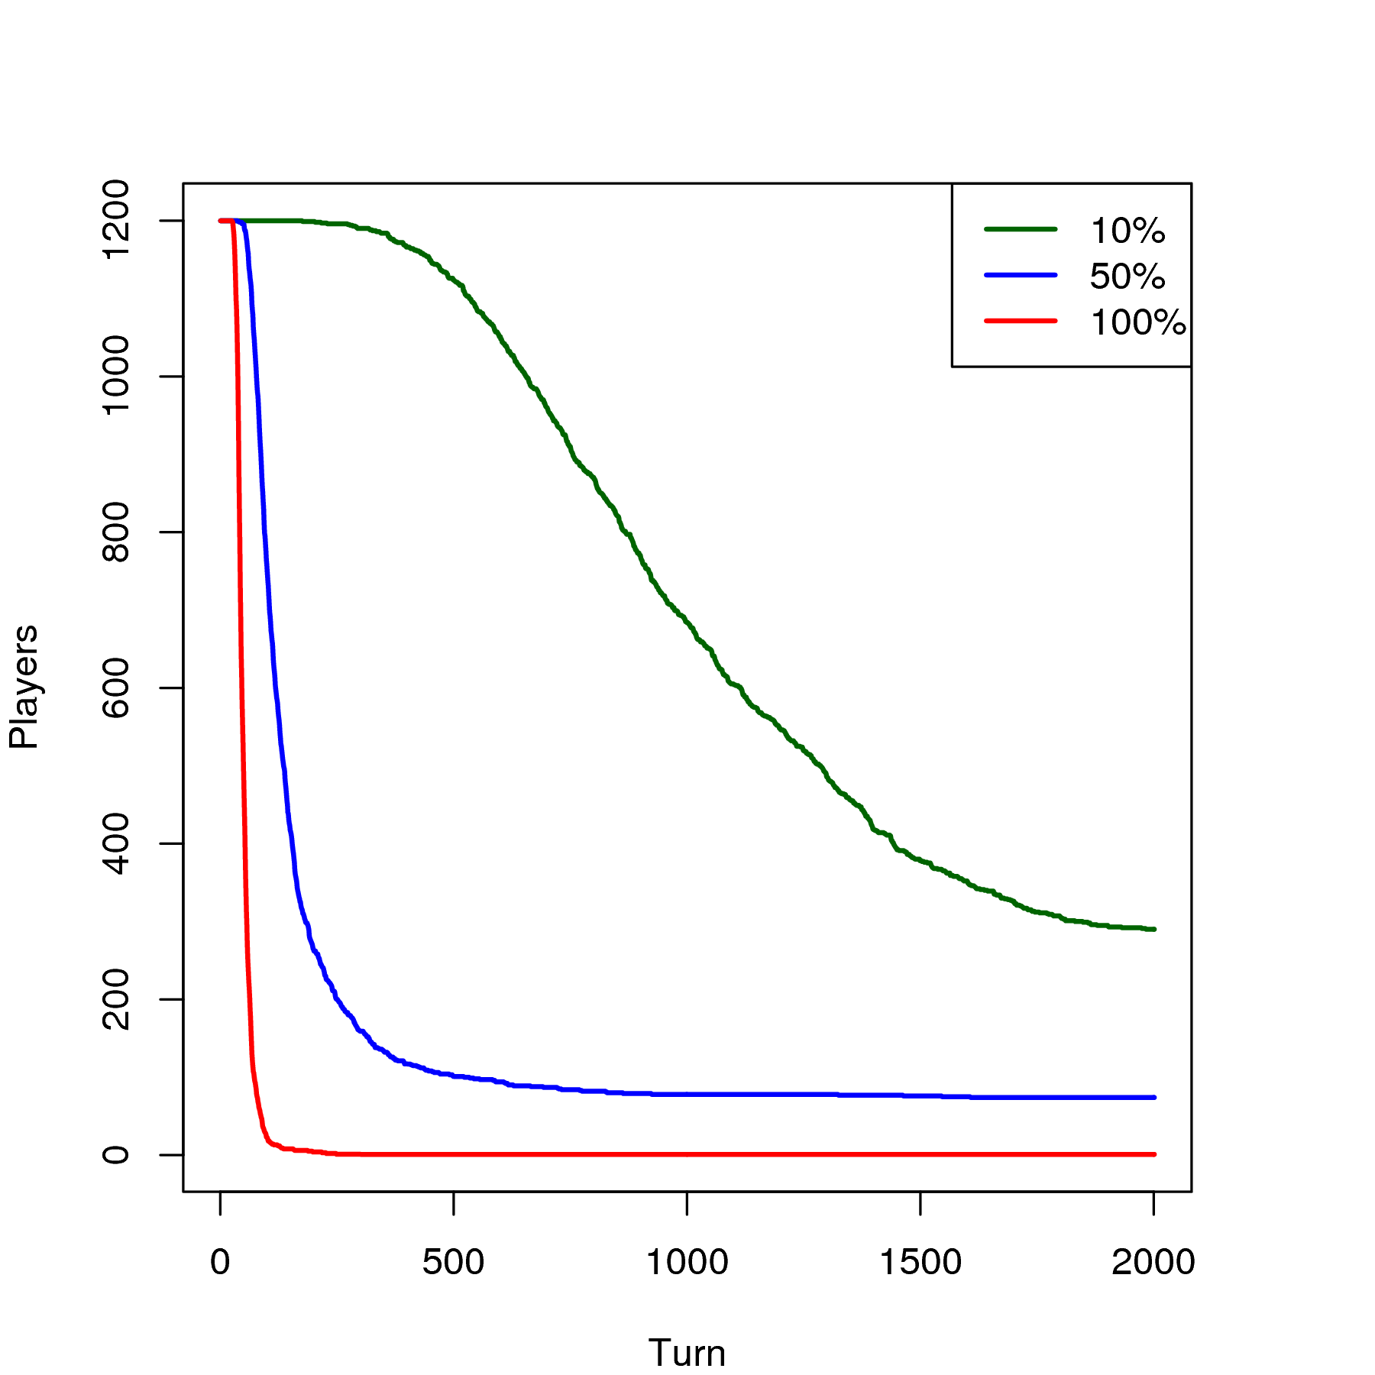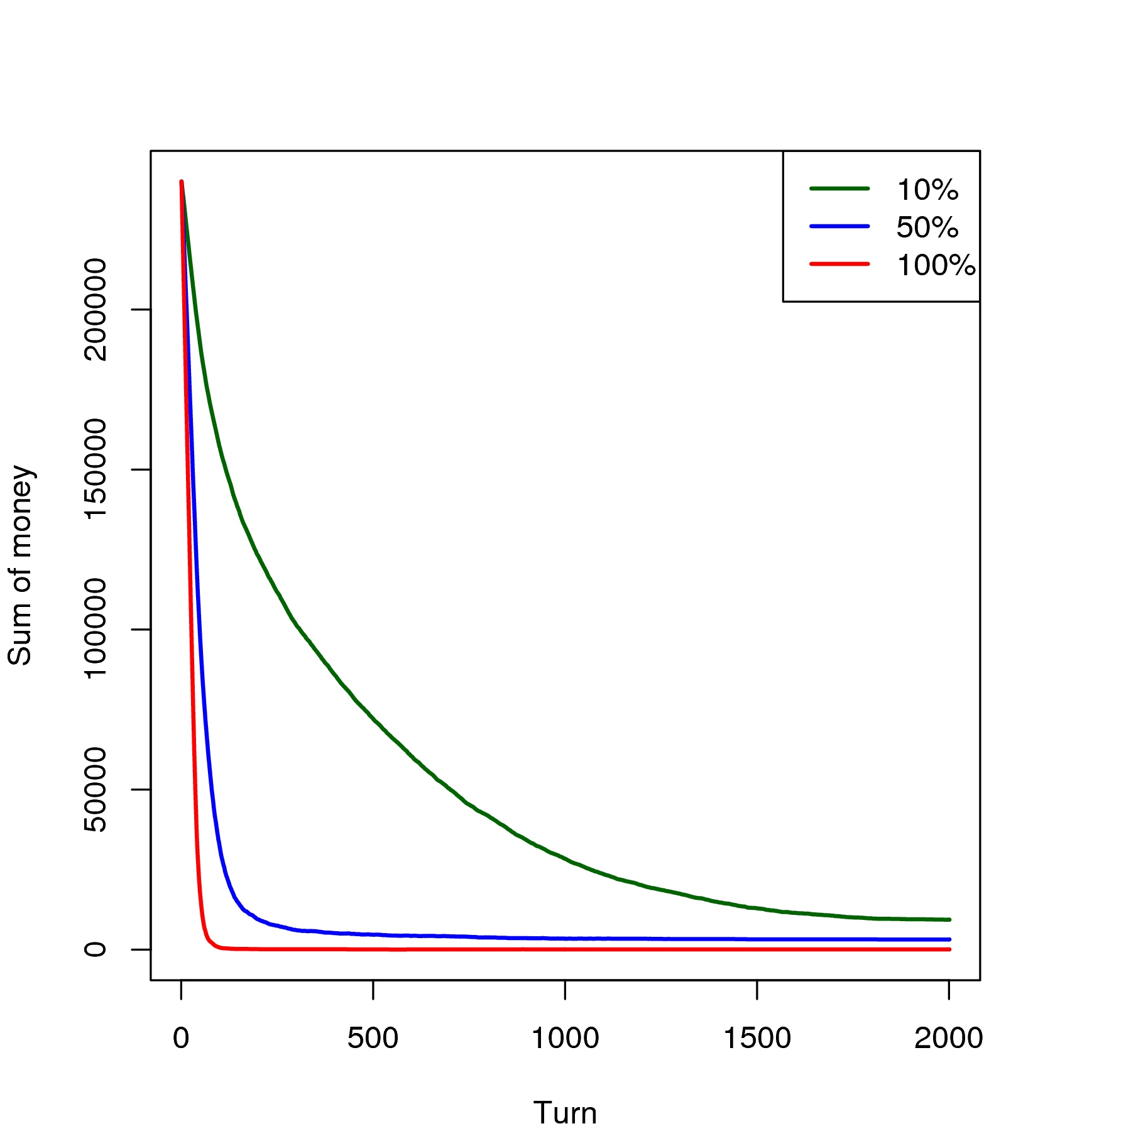

(a) Number of players (b) Money by groups
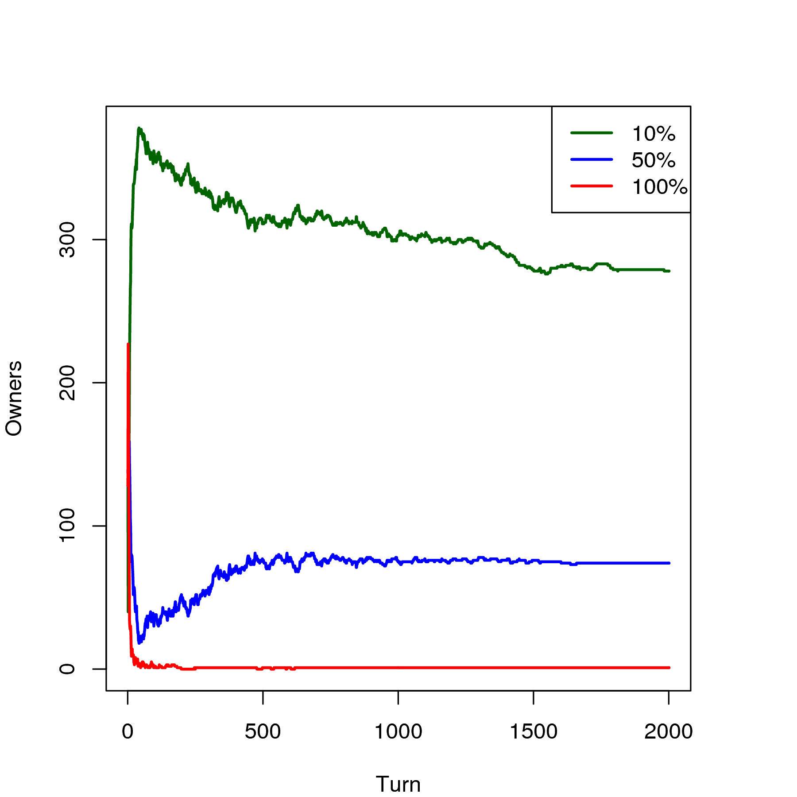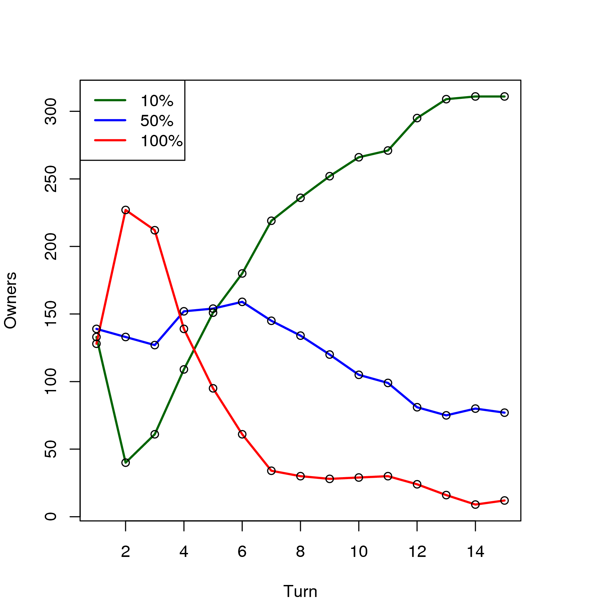

(c) Owners by groups (d) Owners in the first 15 iterations

Figure 1. Initial results

Figure 2 shows the movements of the three groups during the first turns of the game. More aggressive players reach the threshold with more frequency, until they start to be removed from the game, and the number of movements is reduced until the game stabilizes.

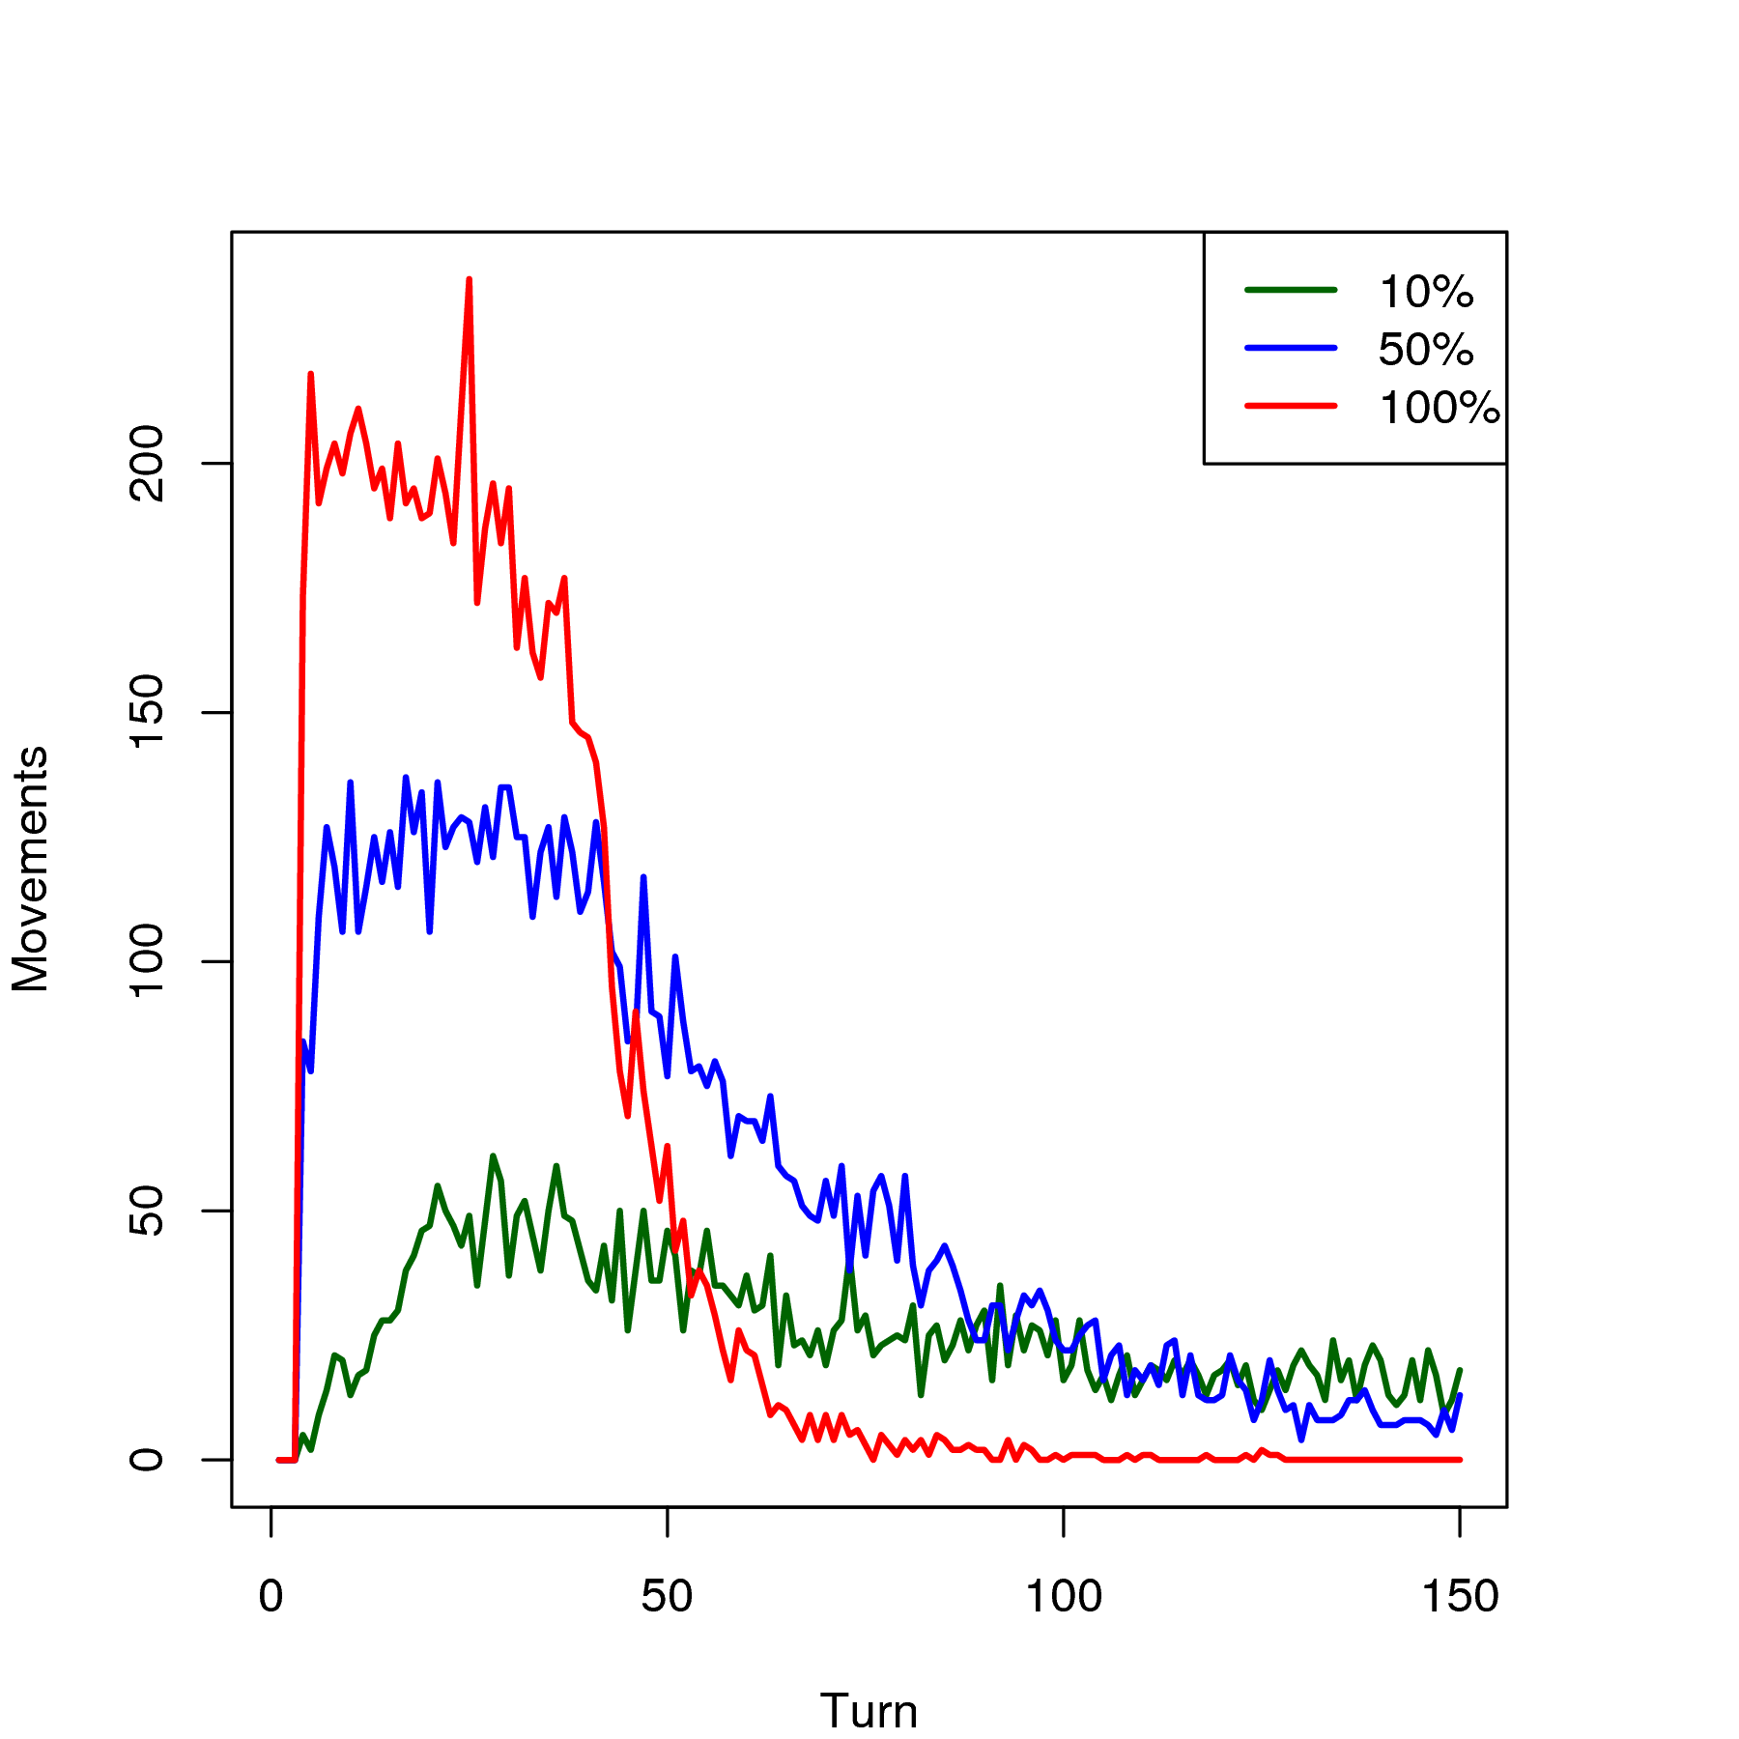

Figure 2. Movements in the first 150 turns
5. Variations of the first model
The first model shows that the equilibrium is the best strategy for the competition against the other two presented strategies. This section describes three experiments based in the initial model, concerning how characteristics of the space may affect the results of the game.

5.1. Infinite money
The initial money can be increased sufficiently to keep all the players in the game until the end of the simulation. With it, the model has a continuous repetition of the initial instability of the original model, as shown in Figure 3. This instability is highly favorable to equilibrium players, that own more than 85% of the cells, from the 30th turn on.
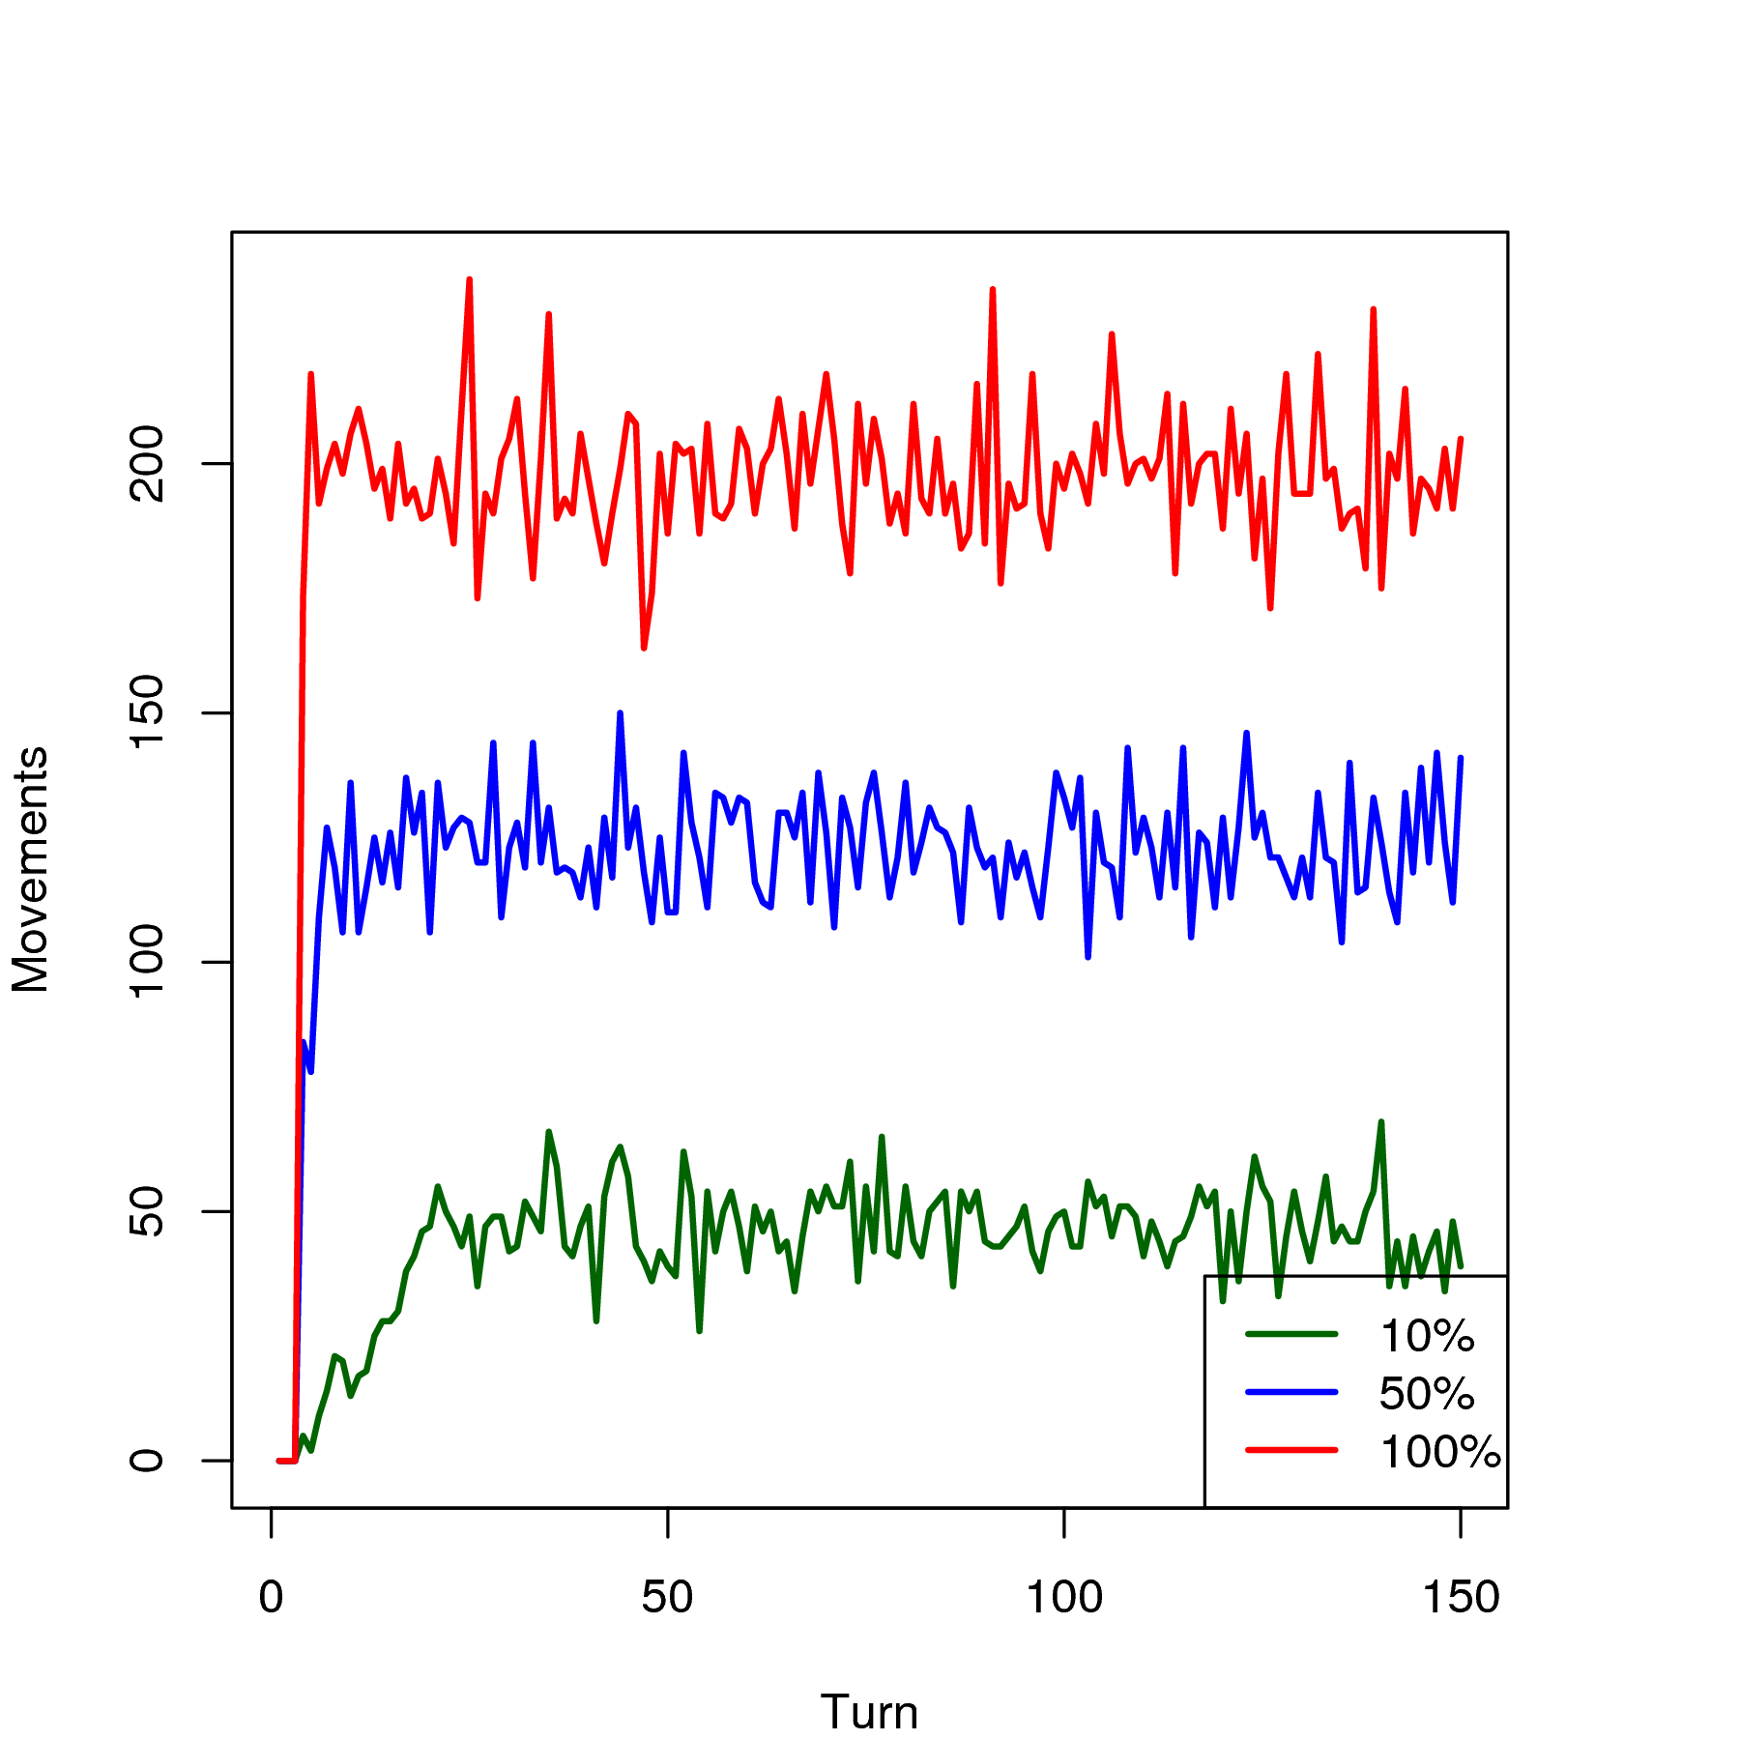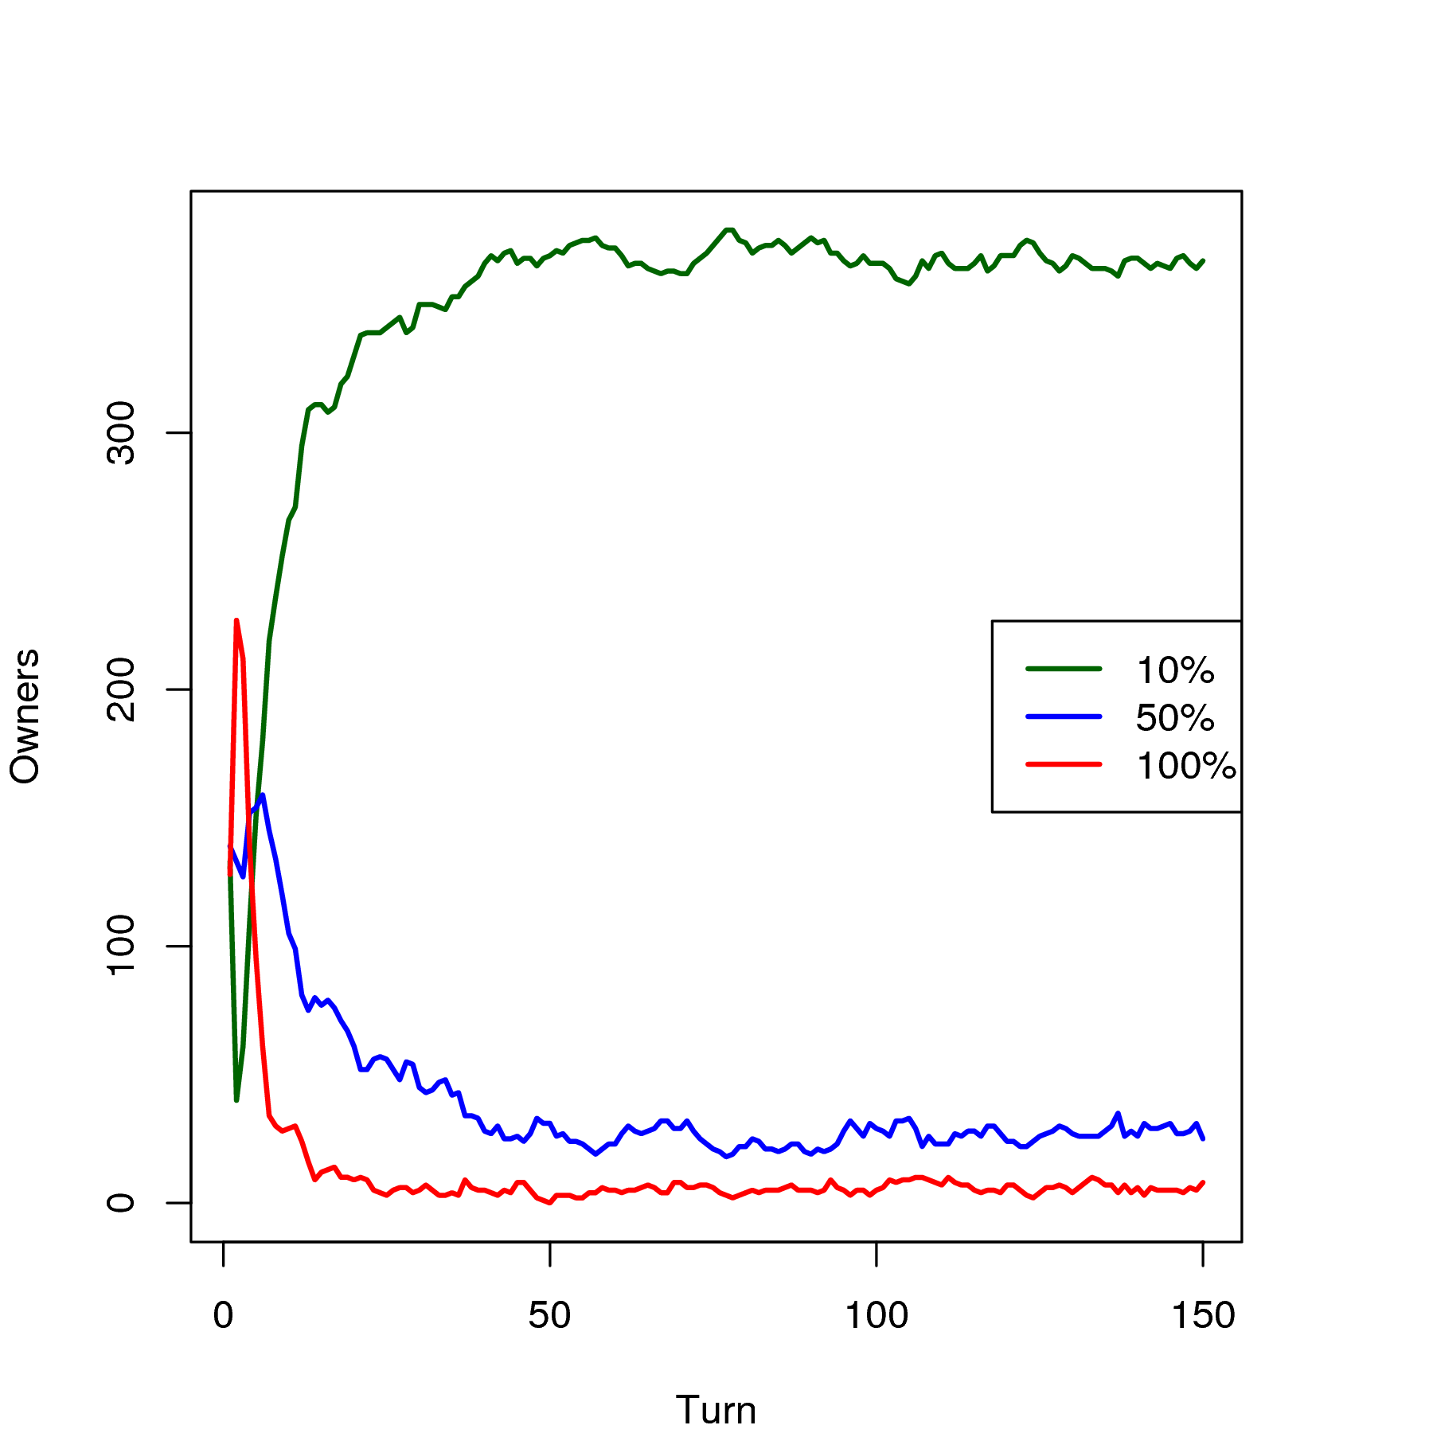
(a) Movements (b) Owners

Figure 3. Game with infinite money

It is possible to calculate the expected payoff of each player, supposing a nonspatial environment, in order to compare it with the mean number of movements of the simulation. If the players meet randomly with equal chances for each group, the expected payoff of a player is the mean expected payoff against each group. The number of turns necessary for a player of a given group to reach the threshold for moving is straight from this value, since the threshold is -20. Then, as there are 1200 players in each group, the mean number of players that would move each turn can be calculated. Table 2 shows these values, and in the lower part there are the difference between the expected movements in a non-spatial model and the results of the experiments for each group. Clearly the results are below the calculated values, because each player can choose a more convenient cell to stay. But, as more a player shoots, he can find an unfavorable arrangement earlier, and therefore it justifies the fact that the reduction is proportional to the shooting rate.

Table 2. Impact of the shooting rate in the movement

 | 10% | 50% | 100%
Against 10% | -0.10 | -0.10 | -0.10
Against 50% | -0.90 | -2.50 | -4.50
Against 100% | -1.90 | -5.50 | -10.00
Mean | -0.97 | -2.70 | -4.87
Turns before a player moves | 20.61 | 7.40 | 4.10
Expected movements by turn | 58.22 | 162.16 | 292.68
Movements with infinite money | 47.25 | 123.20 | 196.13
Difference | 10.97 | 38.96 | 96.55
Reduction (%) | 18.84 | 24.02 | 32.98

5.2. Gain
The second variation of the initial model stills concerning the reduction of the number of players along the game. Instead of increasing the money to the players, this model gives a gain to both players at the end of each game, with the objective of keeping them alive. The game is the same, and therefore the equilibrium does not change. Six values of gain were used in the model: +0.1, +0.2, +0.4, +0.8, +1.6 and +3.2.
The number of players in the model at the end of the turn 6000 is shown in Figure 4. After that, the model has only some minor changes. The total amount of players that survive arises along with the gain, and players with a sharper shooting rate has a slower tax of increase.
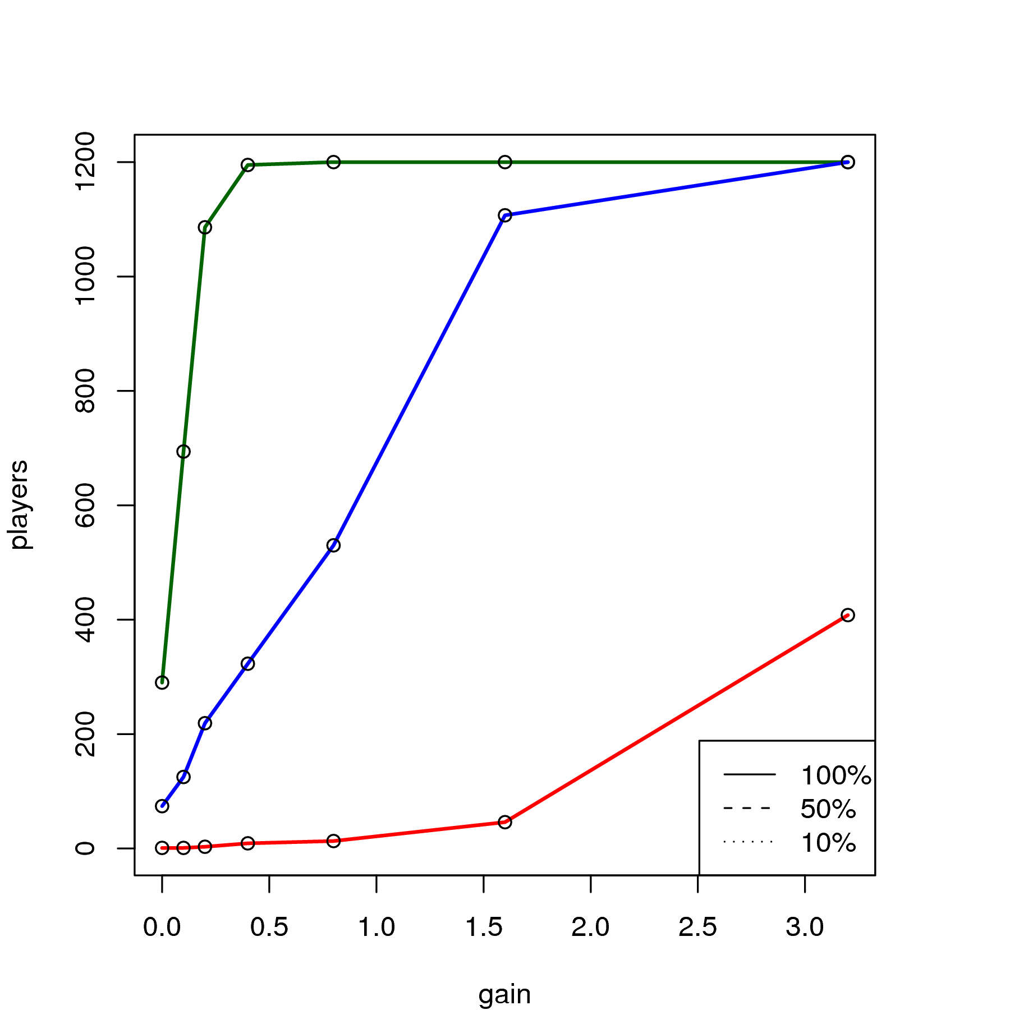
Figure 4. Players after turn 6000 with gain

The owners of for the six classes of gain can be seen in Figure 5. As the gain increases, players with a low tax of shoot stop to reach the threshold for moving, and start to stand still in the cells. The first class to loose mobility is 0.1, and therefore they loose the cells majority for 0.5 players with gain +0.2, +0.4 and +0.8. After the gain +0.4, 0.5 players also start to loose mobility, and therefore cells, and finally with gain +1.6 they already has lost the majority of the cells again for 0.1 players. A bigger increase of gain do not lead 1.0 players to reach the majority, because they have a major problem of selfdestruction. But the impact of the mobility loss can also be seen in the gain +3.2, where 1.0 players are the only ones that have mobility, and therefore they end up the game with more cells than 0.5 players.

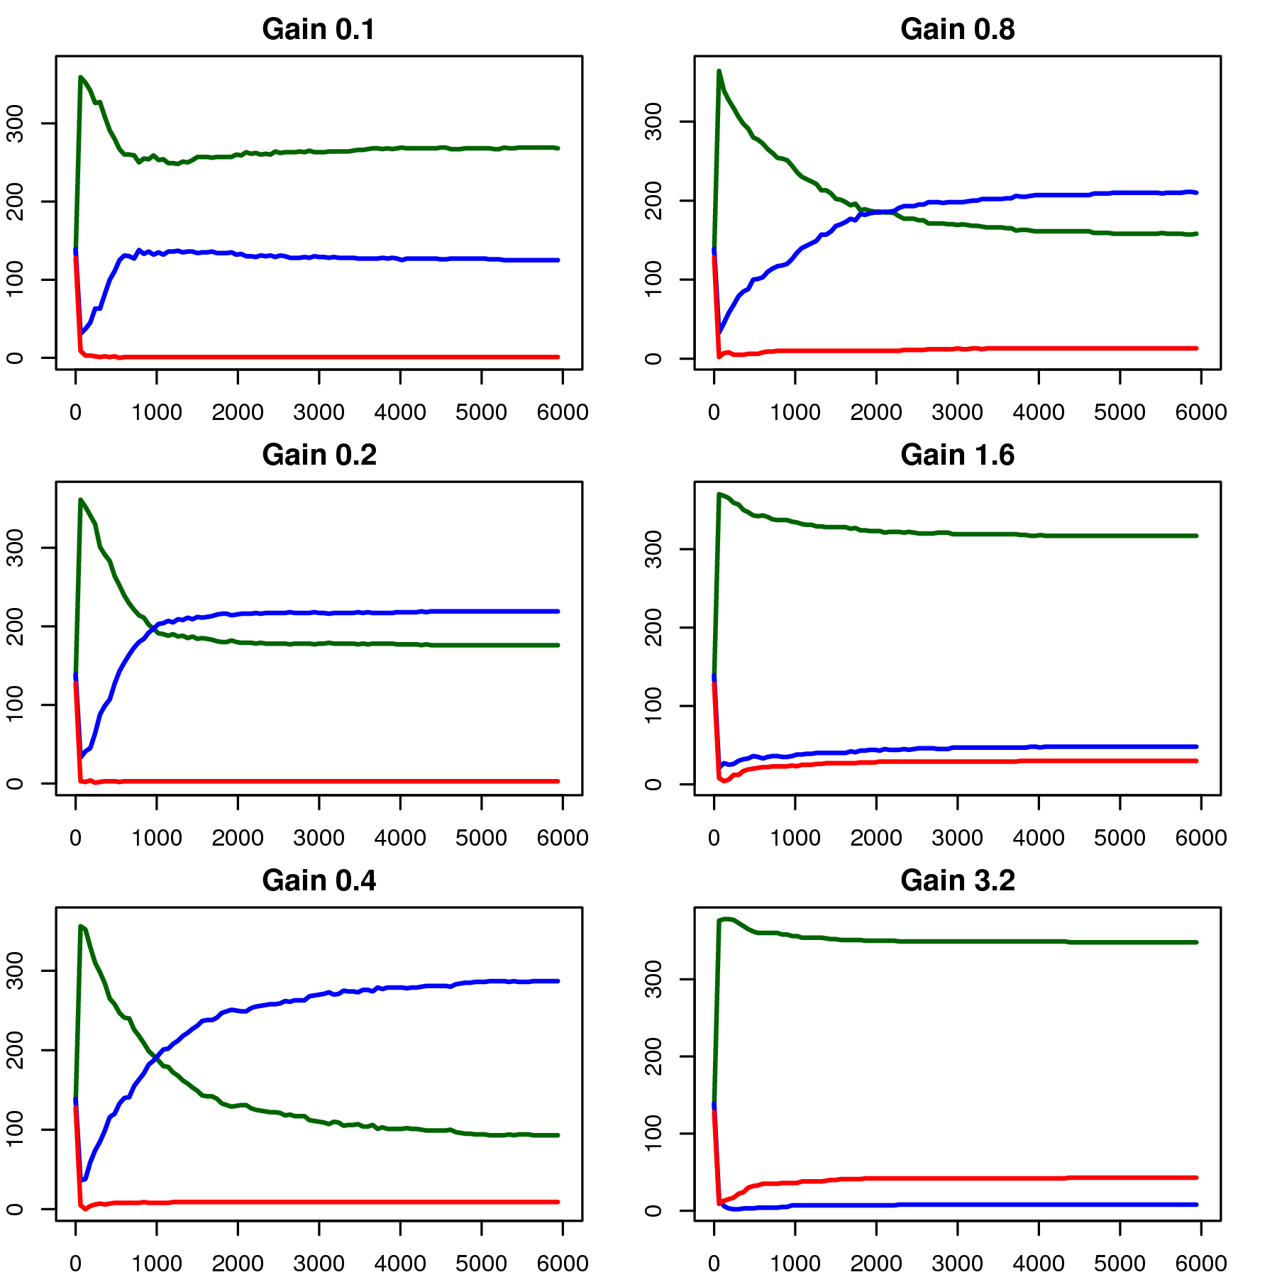
Figure 5. Owners with gain

5.3. Eleven strategies
The third variation of the model investigates the best strategy in a more heterogeneous environment. The model is composed by players following eleven distinct strategies of shooting: 0.0, 0.1, . . . , 0.9 and 1.0. Each class has 1200 players, and the rules are the same of the first model.
The results of cell owners can be seen in Figure 6, showing in evidence the strategies, the equilibrium and the ones right above (0.2) and below (0.0). In the first turns the three strategies had the same negative results, as the equilibrium in the initial model, but each group has a different trajectory along the time. Players that never shoot reach the ownership of half the number of cells quickly, but, as the model evolves, they loose most of them and the model finishes with them in the 6th position. Equilibrium players have success in the game, but they finish the model drawing with 0.3 players, and the strategy that achieve the best result is 0.2. The other strategies follow from top to bottom as the shooting rate increases.
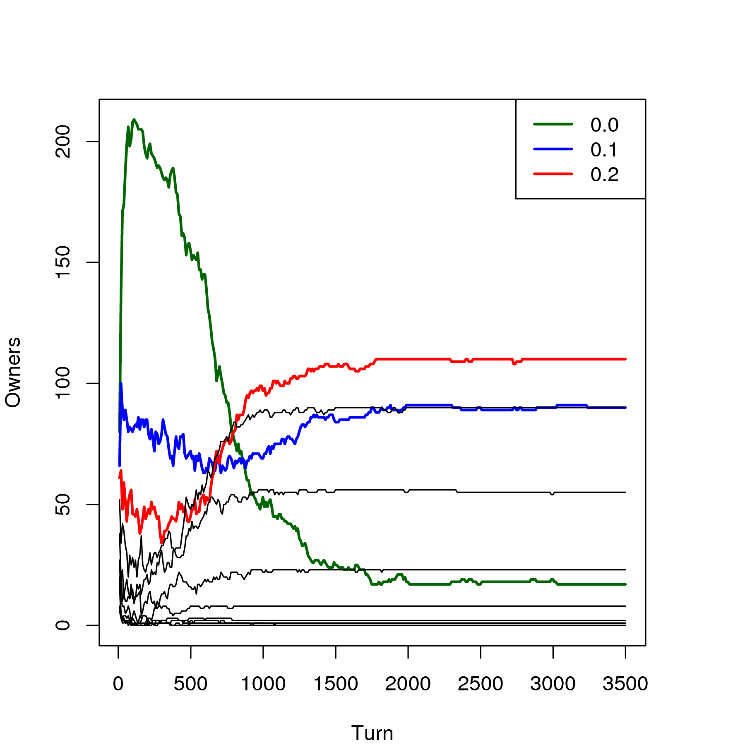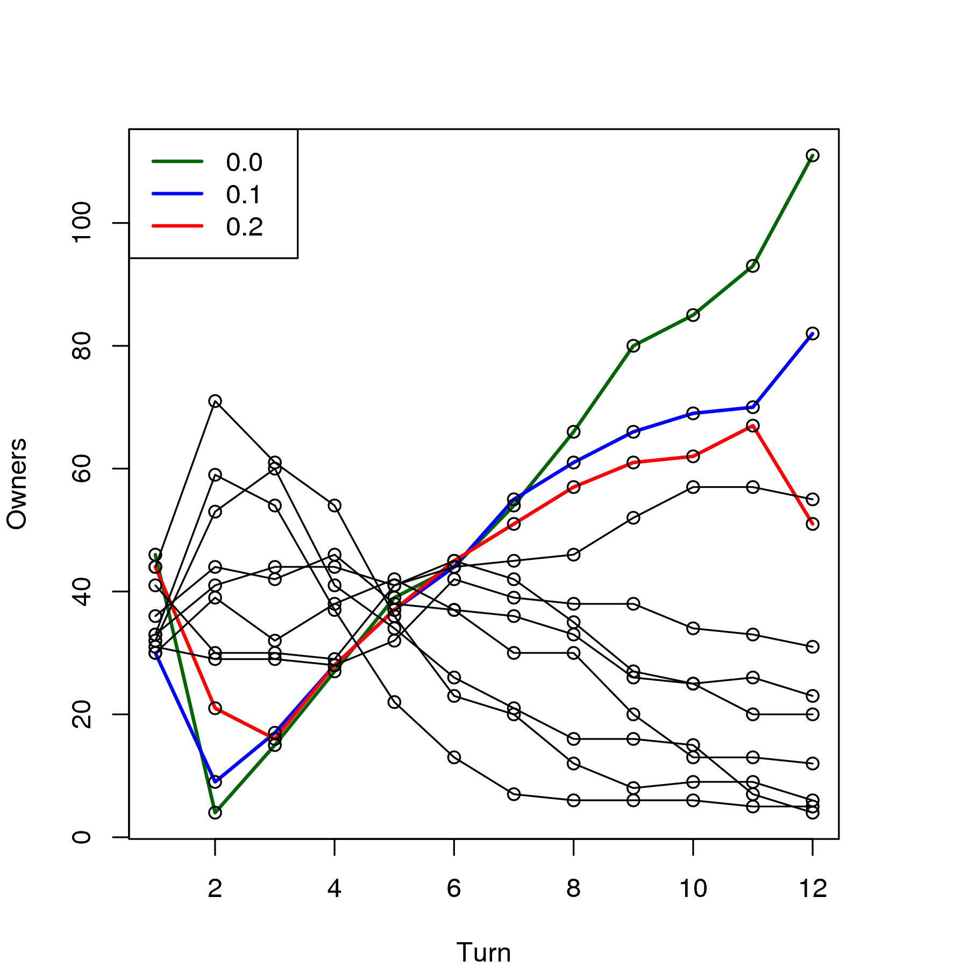
(a) All the game (b) First 12 iterations

Figure 6. Cell owners with eleven strategies

Due to the possibility of having empty cells, as described in the results of the initial model, the strategy of never shooting have own some cells at the end of the simulation. The majority archieved by 0.2 players can be justified with the result of the first variation. As a player shoots more, he can perceive a threatening environment earlier. The counterpart of it is the destruction of players with the same strategy. The equilibrium is the base for a stable relationship, and it can be used as a basis for the best strategy. In this game the best strategy uses the equilibrium, but risking some more in order to get mobility leads to the victory, and 0.2 players have indeed these characteristics.
6. Conclusions
This paper presents a new model for studying spatial games, where players compete for cells through a non-cooperative game. Players are allowed to move in the space, and all them have the same reasoning for the decision of when to leave a cell.
The results of the experiments show that characteristics from the space that alters the mobility lead to the success of distinct strategies, even the ones far from equilibrium. The results also show that risky players take more advantage of the space, because they can perceive an unfavorable environment earlier, but it has a counteraction of selfdestruction. Therefore there exists a new equilibrium between these two factors, and the experiments show that the best strategy joins Nash Equilibrium and some risk. The evidence for this conjecture is shown in the studied game, where the equilibrium point is 0.1, and the more successful strategy was 0.2.
Future works include to study the impact of the threshold for moving, and how fuzzy logic can bring more reality to these models. Another objective is to explore evolutive models concerning population dynamics. New populations are generated from the fittest players of the previous simulation, with some mutation in the characteristics of the agents.
References

1. Nowak, M.A., Sigmund, K.: Games on Grids. In: Dieckmann, U., Law, R., Metz, J.A. (eds.): The Geometry of Ecological Interactions: Simplifying Spatial Complexity. Cambridge University Press (2000) 135-150
2. Nowak, M.A., Sigmund, K.: Evolutionary Dynamics of Biological Games. Science 303 (2004) 793
3. Hutson, V., Vickers, G.T.: Methods for reaction-diffusion models. 2000). The Geometry of Ecological Interactions. Simplifying Spatial Complexity. Cambridge Studies in Adaptive Dynamics, Cambridge: Cambridge University Press; and Laxenburg: International Institute for Applied Systems Analysis (2000) 456-481
4. Metz, J.A.J., Mollison, D., van den Bosch, F.: The dynamics of invasion waves. In: Dieckmann, U., Law, R., Metz, J.A. (eds.): The geometry of ecological interactions: simplifying spatial complexity. Cambridge University Press, Cambridge (2000) 482–512
5. Nash, J.: Non-cooperative games. Annals of Mathematics, Vol. 54 (1951) 286-295
6. Kalai, E., Lehrer, E.: Rational learning leads to Nash Equilibruim. Econometrica 61 (1993)
7. Smith, J.M.: Evolution and the Theory of Games. Cambridge University Press (1982)
8. Darwin, C.: On the Origin of Species. John Murray, London, UK (1859)
9. Hauert, C., Doebeli, M.: Spatial Structure often Inhibits the Evolution of Cooperation in the Snowdrift Game. Nature 428 (2004) 4
10. Mansury, Y., Diggory, M., Deisboeck, T.S.: Evolutionary game theory in an agent-based brain tumor model: Exploring the `genotype-phenotype' link. Journal of Theoretical Biology 238 (2006)
11. Kosmidis, K., Halley, J.M., Argyrakis, P.: Language evolution and population dynamics in a system of two interacting species. Physica A 353 (2005)
12. Vukov, J., Szabò, G.: Evolutionary prisoner's dilemma game on hierarchical o lattices. Physical Review E 71 (2005)
13. Tomassini, M., Luthi, L.: Hawks and Doves on small-world networks. Physical Review E 73 (2006)
14. Liu, Y., Wang, Y., Zhang, Y., Lin, X., Qin, S.: GSQL-R: A query language supporting raster data. IEEE International Geoscience and Remote Sensing Symposium, 2004. IGARSS '04, Vol. 7. IEEE Comnputer Society, Anchorage, USA (2004) 4414- 4417
15. Galliard, J., Ferrière, R., Dieckmann, U.: The adaptive dynamics of altruism e in spatially heterogeneous populations. International Journal of Organic Evolution 57 (2003) 15
16. Hofbauer, J., Sigmund, K.: Evolutionary Games and Population Dynamics. Cambridge University Press, Cambridge, UK (1998)

